* @multipleInheritance  
  #include<iostream>  
  using namespace std;  
     
  class Animal {  
   public:  
   int age;  
   int weight;  
     
   public:  
   void bark() {  
   cout << "Barking " << endl;  
   }  
  };  
  class Human {  
   public:  
   string color;  
   public:  
   void speak() {  
   cout << "Speaking " << endl;  
   }  
  };  
  //Multiple Inheritance  
  class Hybrid: public Animal, public Human {  
  };  
     
  int main() {  
   Hybrid obj1;  
   obj1.speak();  
   obj1.bark();  
     
   return 0;  
  }  
     
  Multiple Inheritance is a feature of C++ where a class can inherit from more than one classes. The constructors of inherited classes are called in the same order in which they are inherited. For example, in the following program, B’s constructor is called before A’s constructor.  
  A class can be derived from more than one base class.  
  Eg:   
  (i) A CHILD class is derived from FATHER and MOTHER class  
  class A  
  {   
  ... .. ...   
  };  
  class B  
  {  
  ... .. ...  
  };  
  class C: public A,public B  
  {  
  ... ... ...  
  };  
     
     
     
     
     
     
     
     
     
     
     
     
     
     
     
  ---------------------------  
  @Diamond problem  
  **The diamond problem** The diamond problem occurs when two superclasses of a class have a common base class. For example, in the following diagram, the TA class gets two copies of all attributes of Person class, this causes ambiguities.  
  For example, consider the following program.
  + CPP
* #include<iostream>  
  **using** **namespace** std;  
  **class** Person {  
   // Data members of person   
  **public**:  
   Person(**int** x) { cout << "Person::Person(**int** ) called" << endl; }  
  };  
     
  **class** Faculty : **public** Person {  
   // data members of Faculty  
  **public**:  
   Faculty(**int** x):Person(x) {  
   cout<<"Faculty::Faculty(**int** ) called"<< endl;  
   }  
  };  
     
  **class** Student : **public** Person {  
   // data members of Student  
  **public**:  
   Student(**int** x):Person(x) {  
   cout<<"Student::Student(**int** ) called"<< endl;  
   }  
  };  
     
  **class** TA : **public** Faculty, **public** Student {  
  **public**:  
   TA(**int** x):Student(x), Faculty(x) {  
   cout<<"TA::TA(**int** ) called"<< endl;  
   }  
  };  
     
  **int** main() {  
   TA ta1(30);  
  }  
  Person::Person(int ) called  
  Faculty::Faculty(int ) called  
  Person::Person(int ) called  
  Student::Student(int ) called  
  TA::TA(int ) called  
  In the above program, constructor of ‘Person’ is called two times. Destructor of ‘Person’ will also be called two times when object ‘ta1’ is destructed. So object ‘ta1’ has two copies of all members of ‘Person’, this causes ambiguities. *The solution to this problem is ‘virtual’ keyword*. We make the classes ‘Faculty’ and ‘Student’ as virtual base classes to avoid two copies of ‘Person’ in ‘TA’ class.  
     
     
     
  For example, consider the following program.
  + CPP
* #include<iostream>  
  **using** **namespace** std;  
  **class** Person {  
  **public**:  
   Person(**int** x) { cout << "Person::Person(**int** ) called" << endl; }  
   Person() { cout << "Person::Person() called" << endl; }  
  };  
     
  **class** Faculty : **virtual** **public** Person {  
  **public**:  
   Faculty(**int** x):Person(x) {  
   cout<<"Faculty::Faculty(**int** ) called"<< endl;  
   }  
  };  
     
  **class** Student : **virtual** **public** Person {  
  **public**:  
   Student(**int** x):Person(x) {  
   cout<<"Student::Student(**int** ) called"<< endl;  
   }  
  };  
     
  **class** TA : **public** Faculty, **public** Student {  
  **public**:  
   TA(**int** x):Student(x), Faculty(x) {  
   cout<<"TA::TA(**int** ) called"<< endl;  
   }  
  };  
     
  **int** main() {  
   TA ta1(30);  
  }  
  Output:  
  Person::Person() called  
  Faculty::Faculty(int ) called  
  Student::Student(int ) called  
  TA::TA(int ) called  
  In the above program, constructor of ‘Person’ is called once. One important thing to note in the above output is, *the default constructor of ‘Person’ is called*. When we use ‘virtual’ keyword, the default constructor of grandparent class is called by default even if the parent classes explicitly call parameterized constructor.  
     
     
     
  **How to call the parameterized constructor of the ‘Person’ class?**The constructor has to be called in ‘TA’ class.  
  For example, see the following program.
  + CPP

#include<iostream>  
**using** **namespace** std;  
**class** Person {  
**public**:  
 Person(**int** x) { cout << "Person::Person(**int** ) called" << endl; }  
 Person() { cout << "Person::Person() called" << endl; }  
};  
   
**class** Faculty : **virtual** **public** Person {  
**public**:  
 Faculty(**int** x):Person(x) {  
 cout<<"Faculty::Faculty(**int** ) called"<< endl;  
 }  
};  
   
**class** Student : **virtual** **public** Person {  
**public**:  
 Student(**int** x):Person(x) {  
 cout<<"Student::Student(**int** ) called"<< endl;  
 }  
};  
   
**class** TA : **public** Faculty, **public** Student {  
**public**:  
 TA(**int** x):Student(x), Faculty(x), Person(x) {  
 cout<<"TA::TA(**int** ) called"<< endl;  
 }  
};  
   
**int** main() {  
 TA ta1(30);  
}  
Output:  
Person::Person(int ) called  
Faculty::Faculty(int ) called  
Student::Student(int ) called  
TA::TA(int ) called  
In general, it is not allowed to call the grandparent’s constructor directly, it has to be called through parent class. It is allowed only when ‘virtual’ keyword is used.  
As an exercise, predict the output of following programs.  
   
   
   
   
@**Diamond Problem  
What is Diamond Problem in C++?**In C++, inheritance is the concept that allows one class to inherit the properties and methods of another class. Multiple inheritance is one such type of inheritance that allows a class to inherit from more than one base class. While this feature provides greater flexibility in modelling real-world relationships, it also introduces complexities, one of which is the Diamond Problem.  
**Diamond Problem**The Diamond Problem is an ambiguity error that arises in multiple inheritance when a derived class inherits from two or more base classes that share a common ancestor. This results in the inheritance hierarchy forming a diamond shape, hence the name “Diamond Problem.” The ambiguity arises because the derived class has multiple paths to access members or methods inherited from the common ancestor, leading to confusion during method resolution and member access.  
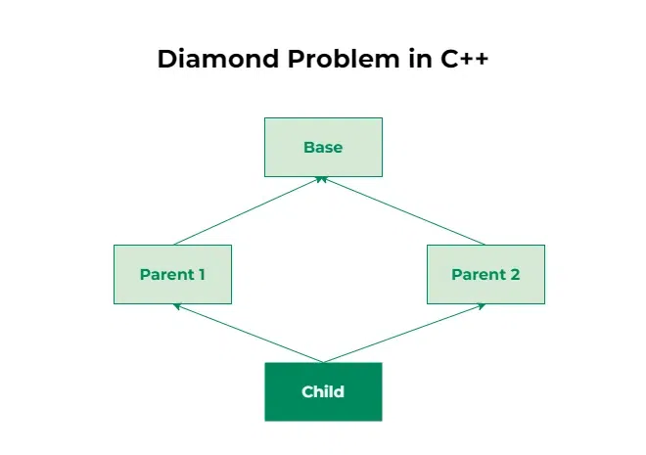  
*// C++ Program to illustrate the diamond problem*#include *<iostream>***using namespace std**;  
*// Base class***class Base** {  
**public**:  
 void fun() { cout << "Base" << endl; }  
};  
*// Parent class 1***class Parent1** : **public** Base {  
**public**:  
};  
*// Parent class 2***class Parent2** : **public** Base {  
**public**:  
};  
*// Child class inheriting from both Parent1 and Parent2***class Child** : **public** Parent1, **public** Parent2 {  
};  
int main()  
{  
 Child* obj = **new** Child();  
 obj->fun(); *// Abiguity arises, as Child now has two copies of fun()* **return** 0;  
}  
   
**Output**main.cpp:30:9: error: request for member ‘fun’ is ambiguous  
 30 | obj.fun(); // Ambiguity error  
 | ^~~  
main.cpp:8:10: note: candidates are: ‘void Base::fun()’  
 8 | void fun() { cout << "Base" << endl; }  
 | ^~~  
main.cpp:20:10: note: ‘void Base::fun()’  
**Solution to the Diamond Problem in C++**C++ addresses the Diamond Problem using virtual inheritance. Virtual inheritance ensures that there is only one instance of the common base class, eliminating the ambiguity.  
*// C++ Program to illustrate the use of virtual inheritance  
// to resolve the diamond problem in multiple inheritance*#include *<iostream>***using namespace std**;  
*// Base class***class Base** {  
**public**:  
 void fun() { cout << "Base" << endl; }  
};  
*// Parent class 1 with virtual inheritance***class Parent1** : **virtual public** Base {  
**public**:  
};  
*// Parent class 2 with virtual inheritance***class Parent2** : **virtual public** Base {  
**public**:  
};  
*// Child class inheriting from both Parent1 and Parent2***class Child** : **public** Parent1, **public** Parent2 {  
};  
int main()  
{  
 Child* obj = **new** Child();  
 obj->fun(); *// No ambiguity due to virtual inheritance* **return** 0;  
}  
**Output**Base  
**Another approach is to rename conflicting methods** in the derived classes to avoid ambiguity. By providing distinct names for methods inherited from different base classes, developers can eliminate ambiguity without resorting to virtual inheritance. However, this approach may lead to less intuitive code and increased maintenance overhead.